3 Branches of Government
American History, the Founding Principles, Civics and Economics

ECONOMICS | CIVICS AND GOVERNMENT | FINANCIAL LITERACY
CE.E.1.2  CE.E.1.6  CE.E.2.1 | CE.C&G.1.4  CE.C&G.2.1  CE.C&G.2.6  CE.C&G.2.7  CE.C&G.5.3  CE.C&G.5.4  CE.C&G.5.5 | CE.PFL.1.2

Essential Standard Correlations:
Unit Overview:
Executive / Legislative / Judicial Branch / Qualifications / Terms / Roles and Responsibilities / Separation of Powers

Unit 4
Conceptual Lens:
Balance of Power

Civics and Government

- Legislative Branch
US Congress
How a Bill Becomes a Law

- Executive Branch
President
Cabinet
Executive Agencies and Departments

- Judicial Branch
Supreme Court
Qualifications

CONCEPT/CONTENT WEB
Economics
- IRS
- Taxes
- Trade
- Interstate Trade
- Budget
- Deficit
- Revenue
- Expenditure

Conceptual Lens:
Balance of Power

Personal Financial Literacy
- Taxes

Essential Understandings (Generalizations) and Guiding (Essential) Questions:

Leaders are often elected by the people and are expected to represent the interests of the electorate.
- How do the three branches of government work together in order to provide leadership for the people?
- How does the system of checks and balances limit the power of government officials?
- Should Congress be able to pass a law that is unpopular with citizens?
- How do the three branches of government work together in order to provide leadership for the people?
- How does the Constitution provide for leadership within each of the three branches of government?
- Should Supreme Court Justices be elected by the people?
- In what ways does the U.S. Constitution limit the power of public officials?
- How can the different types of revenue impact the government’s ability to operate in the best interest of its citizenry?
- In what ways do government agencies protect the safety of citizens?

Power to govern is sometimes divided among different groups and these groups are often at odds over how best to implement a
Democratic system.
- Should the Supreme Court be the ultimate authority in interpreting the Constitution?
- How might the government’s power to tax impact citizens of varying degrees of wealth?
- Should everyone be forced to pay taxes

Unit Vocabulary

Tier 1 | Tier 2 | Tier 3
Low level, every day basic words  (ex. Leader, fight, win, food and shelter)  Agree  Disagree  Law  Vote  Rules  Separate  Balance | More complex, interdisciplinary words  (ex. President, war, election, resources)  Veto  Treaty  Impeachment  Ratify  Revenue  Expenditure  Vice President  Congress  Cabinet  Incentives  Sanctions  Intervention  Budget  Confirm/Confirmation  Appoint  Nominate  Override  Resolution  Dispute | Content specific, complex words  (ex. Dictator, Forced Colonialism, Democratic Ideals, Supply and Demand)  Filibuster  Executive Order  Legislative  Executive  Judicial  Standing Committee  Conference Committee  Bicameral  Joint Committee  Select Committee  Pocket Veto  Franking Privilege  Checks and Balances  Separation of Power  Federalism  Pardon  Reprieve  Commute  Amnesty  Supreme Court  Gerrymandering  Filibuster

By the end of this unit, students should be able to state…
• I can explain how checks and balances protect democracy.
• I can explain how federalism protects democracy.
• I can explain the qualifications, powers and duties of the legislative branch.
• I can explain how a bill becomes a law.
• I can explain the qualifications, powers and duties of the executive branch.
• I can explain the qualifications, powers and duties of the judicial branch.
• I can outline the structure of the US Constitution.
• I can explain how the Supreme Court has expanded individual rights.
• I can explain how the Supreme Court has limited individual rights.
• I can list executive agencies and explain what they do.
• I can explain the President’s role in foreign affairs.
• I can explain the Senate’s role in foreign affairs.

Performance Task and Scoring Guides/Rubric

Generalizations: Power to govern is sometimes divided among different groups and these groups are often at odds over how best to implement a
Democratic system
Why: To help students master the Bill to Law process
How: Students will create a children’s book to demonstrate understanding of the bill to law process
What: Children’s Book

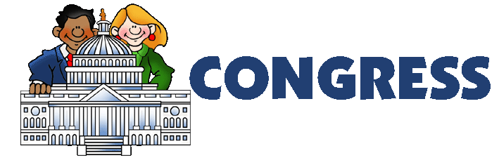
Congress for Kids Project

Directions: Using the information you have learned this week as well other resources, you will compose a short children’s story that explains how congress works. The information below outlines what is to be included. Remember that a kids book takes rigorous information and simplifies it so that all can understand

Resources:

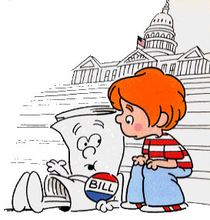
Table Of Contents

Cover: Must include a title and an image with your name at the bottom

Page 1: What is a Congress and a Bicameral Legislator (This is your prologue that tells a story in simplistic language)

Page 2: House of Representatives
- Membership requirements and how membership is determined and proportioned
- What is so important about the Speaker of the House?
- What can only the House of Representatives do?
Page 3: What is the Senate
- Membership requirements and how membership is determined and proportioned
- What is so important about the Senate Pro Temp?
- What can only the Senate do?
- What is a filibuster?
Page 4: Committees
- What is the purpose of a committee?
- Identify and give examples of the three types of committees

* Remember that you must write this so that an elementary school student can understand*

Children’s Book Rubric
Name:
I. Does the presentation clearly address the key concept? 20 points
- Explanation of basic information and important facts
- All subcategories are addressed
- Notes and book incorporates 3 or more facts or ideas not in the textbook
II. Does the presentation maintain the voice of a children’s book? 10 points
- Clear and appropriate vocabulary.
- Clearly organized plot line connected with the assigned topic
- Story addresses clear and specific historical parts of legislative branch

III. Is the presentation neat with appropriate illustrations? 10 points
- One illustration for each page (must be relevant)

Comments: ___/40

Unit Resources

Unit Number -
State and Local Government
Resource Title | Location | Summary
I Civics | I Civics | Comprehensive website that provides games and printable activities for students to learn about the 3 branches of government.
The House of Representatives | The House of Representatives | Official site of the House of Representatives, gives an in depth analysis of the three branches of government
The White House | The White House | Official website of the executive branch that provides overviews of the president’s role and the cabinet
Edsitement | Edsitement: 3 Branches | Provides primary document analysis of the 3 branches of government and discusses separation of powers.
Peter Pappas: Gerrymandering | Peter Pappas: Gerrymandering | PDF that explains gerrymandering and allows students to practice gerrymandering a disctrict
You Tube: Gerrymandering | You Tube: Gerrymandering | 4:00 minute video from TED Talk that explains gerrymandering in an interesting way
Flocabulary: 3 Branches | Flocabulary: 3 Branches | Informative rap video with lyrics and visuals explaining the 3 branches of government
Public Wiki: Executive Branch Activities | Public Wiki | Teacher website that has an entire unit plan for the executive branch.

